Leading Data Connectivity
Phoenix Contact is your key partner for reliable data connections. Intelligent devices are becoming increasingly networked, and the number of interfaces is rising steadily. Therefore, place your trust in our reliable data connectors for the future-proof networking of all communication devices. We understand your challenges for future-proof data connectivity, and will support you with our consulting expertise.

Reliable products for stable data transmission
Whether Industrial Ethernet, fiber-optic technology, or 5G: The demands on the performance of connection technology in field applications are constantly growing. Intelligent devices are becoming increasingly networked. This increases the total number of interfaces. Data connectivity forms the basis for high data rates and stable connections. Consistent quality in data transmission depends on the interaction of all cables and connector components.
Modular and at the same time standardized connectors enable automation solutions for real-time communication to be designed more flexibly and efficiently. As a leading supplier for device manufacturers, Phoenix Contact provides the right connection on the device and in the field for your applications.

Your advantages
- We understand your challenges concerning future-proof data transmission: Get the right solution for your device interface with our consulting expertise
- Data connectors of exceptional quality: Decades of reliable device communication
- More individuality: Get your customized item within a few business days
- Design-in support: Fast connector solutions with CAx download files and sample service
- Future-proof networking of all communication interfaces: Continuous portfolio evolution and trending technologies such as SPE

Our portfolio for data transmission in detail

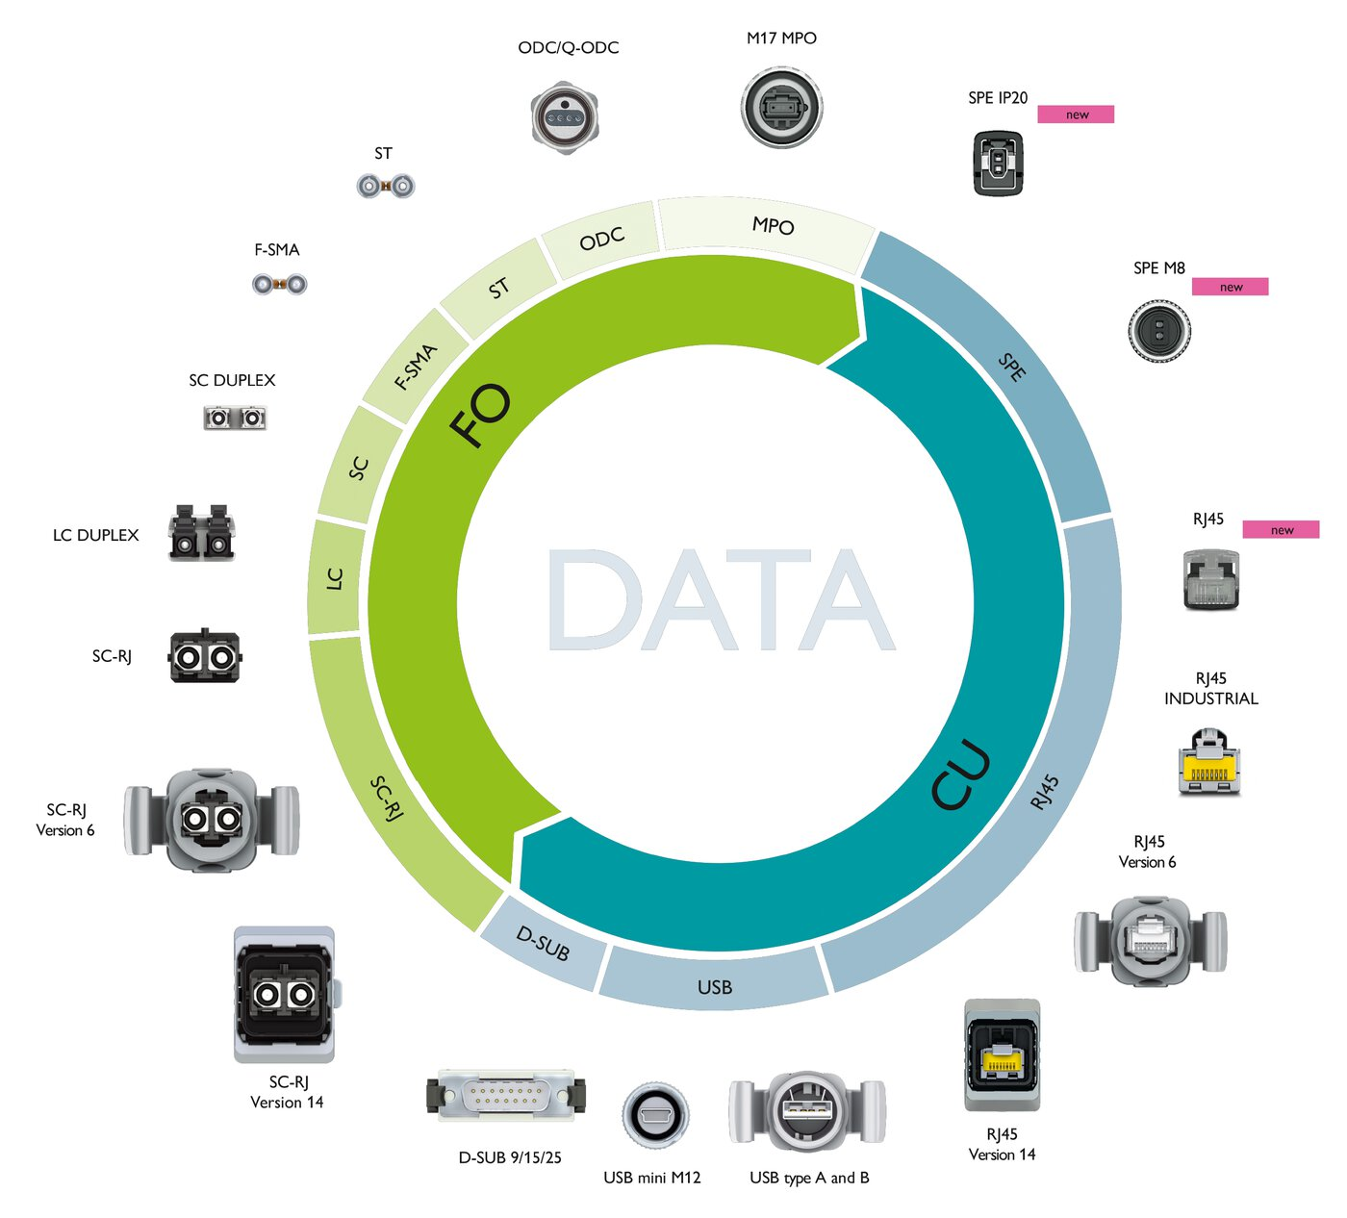
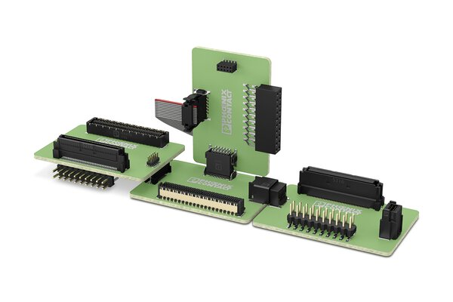
Board-to-board connectors
Shielded and unshielded data transmission in the tightest of spaces: Easily implement PCB alignments in all dimensions with board-to-board connectors.
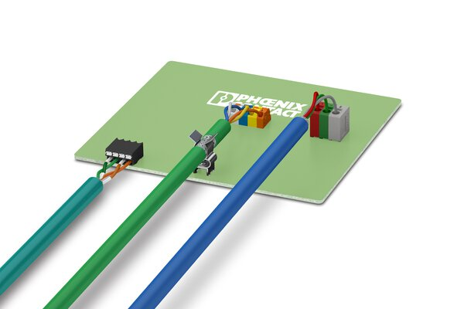
PCB terminal blocks
From process interfaces, through automation components, right through to frequency converters: PCB terminal blocks for data transmission offer ideal connection solutions for your application.
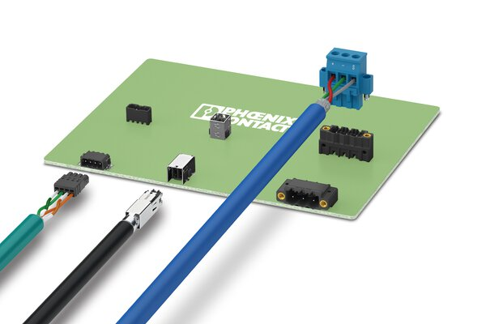
PCB connectors
PCB connectors for data transmission are available with innovative connection technologies and in numerous versions. Assembled solutions are also possible.

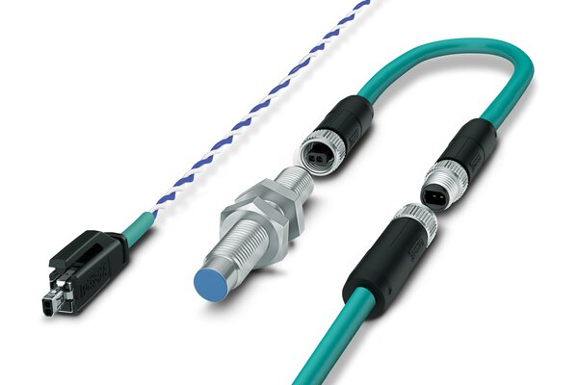
Connectors for Single Pair Ethernet
The IP20 and M8 device and cable connectors for Single Pair Ethernet ensure efficient data transmission in factory and process automation.
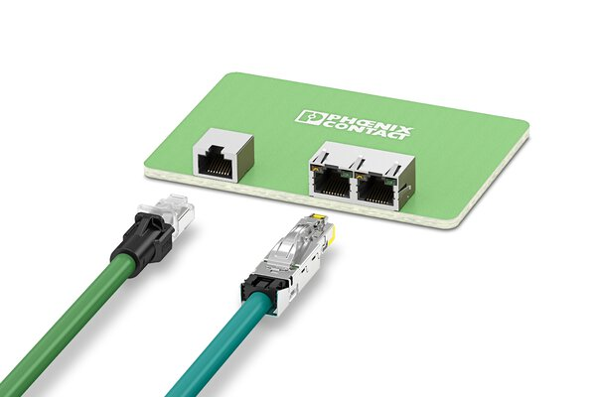
RJ45 connectors
Compact RJ45 connectors and patch cables support high-speed data transmission of up to 10 Gbps.
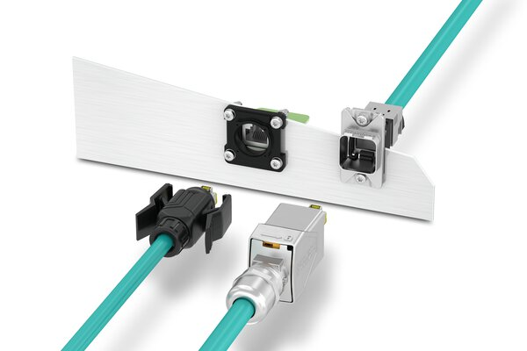
V6 and V14 connectors
Version 6 and version 14 connectors are suitable for field and industrial applications that require high IP protection classes.

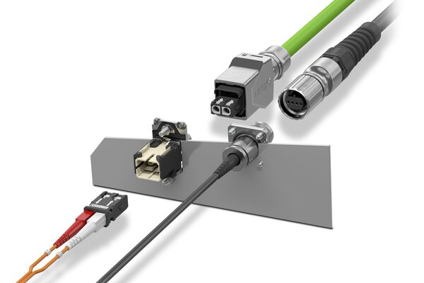
FO-based data connectors
High transmission speed for networks and field buses: Fiber-optic connectors and cables enable high-speed data transmission in industrial and infrastructure applications.
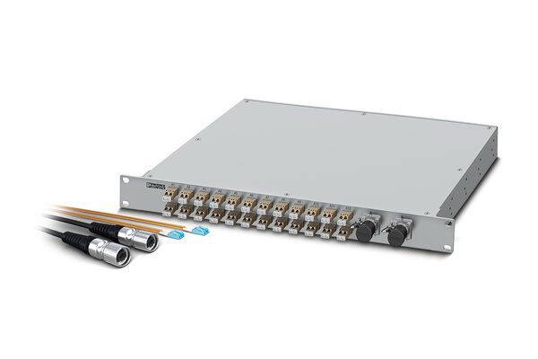
Distributor solutions
Splice boxes and connectors of the M17 MPO series enable efficient distribution solutions in the control cabinet.
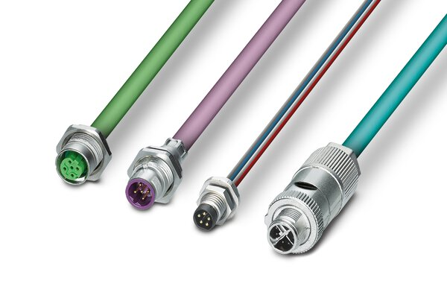
M8 and M12 data connectors
Two-piece circular connectors in M8 and M12 designs for PCB mounting offer a wide range of connection options for wave, THR, and SMT soldering processes.

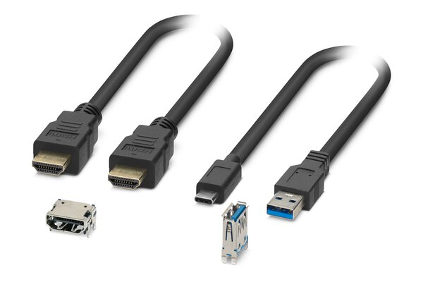
HDMI and USB connectors
PCB connectors and patch cables with HDMI and USB interfaces extend the portfolio for high-speed data transmission in protected applications.
To the product list
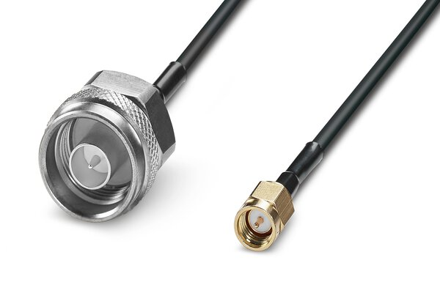
Coaxial connectors
Coaxial connectors provide ideal device solutions for the transmission of WLAN, Bluetooth, LTE, and 5G signals. Assembled cables are also available.
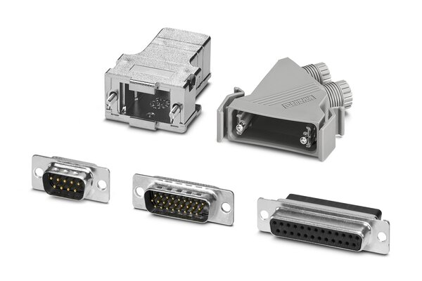
D-SUB connectors
D-SUB sleeve housings and D-SUB contact carriers provide you with ideal solutions for cabling bus systems.

Ideal for these applications
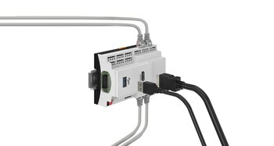
Controllers and housings
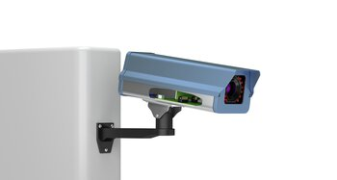
Surveillance cameras
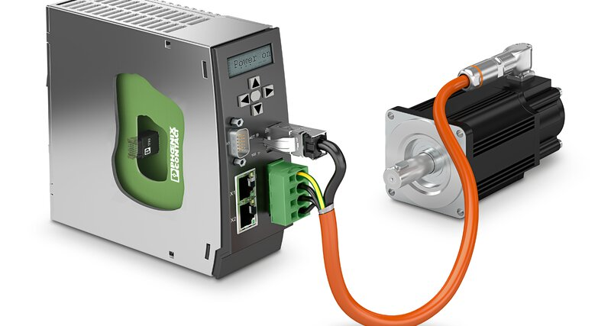
Motor controllers
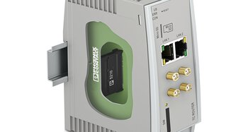
5G routers
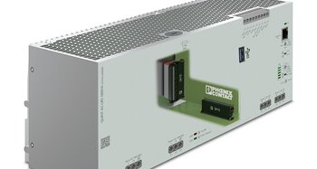
Power supply units
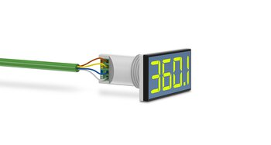
Displays
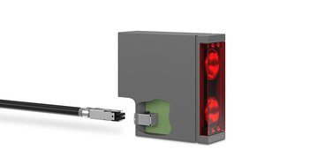
Security

